**Cost Centre Hierarchy**

Below job needs to be triggered from control-M.

Control M Job : **FMSGB_P_NZL_OIC_04AD**  
Run Control : **NZL_ANZ_GEN_EXTR_CCO_D1**

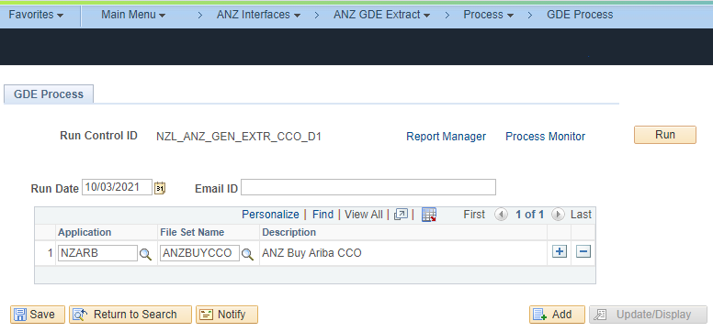

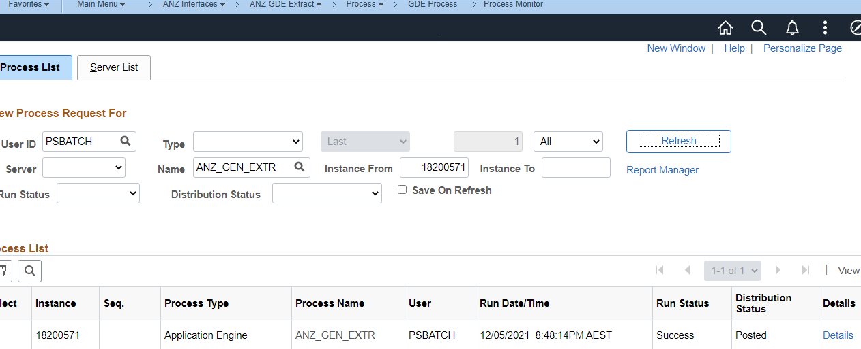

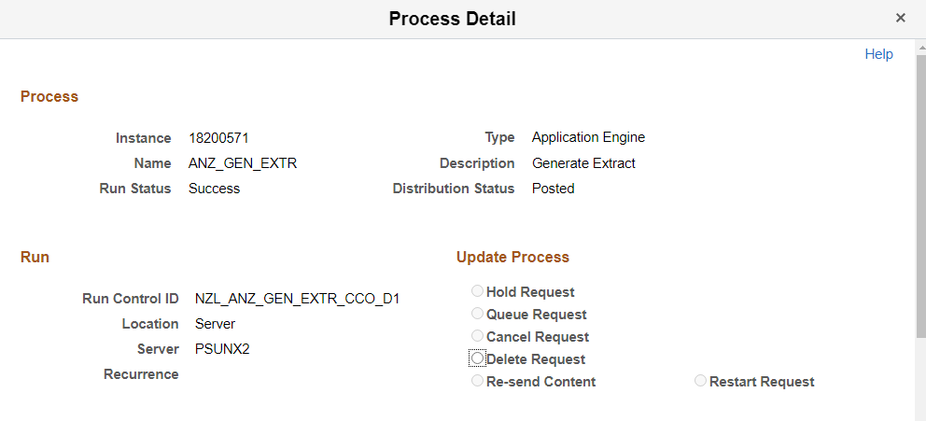

File generated in the specified NAS.

